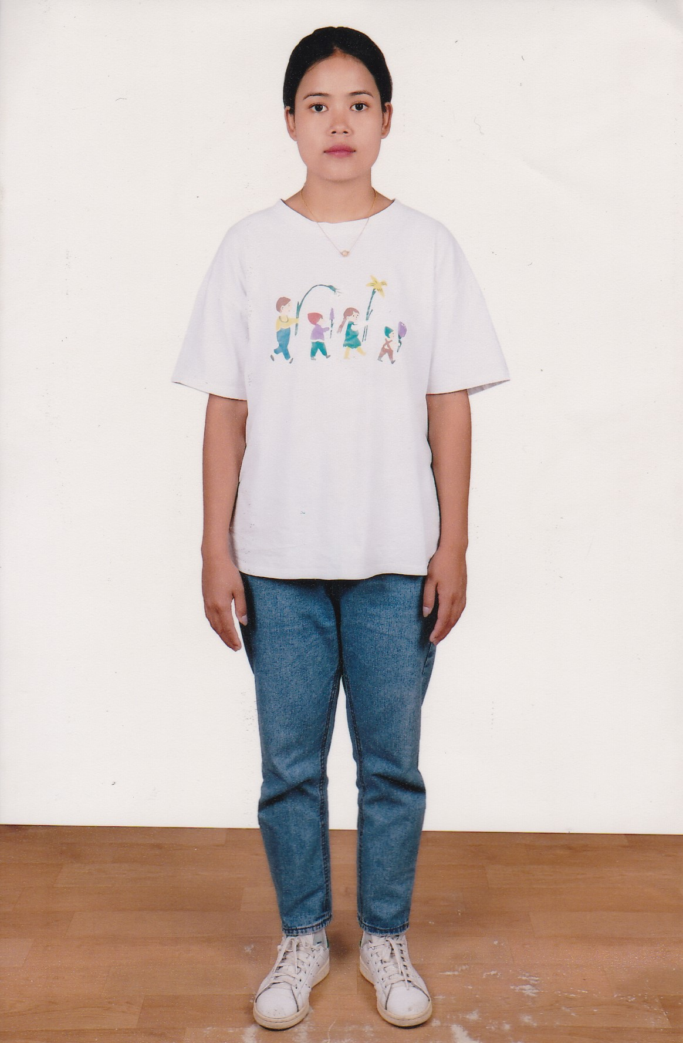
WHOLE BODY PICTURE
KNOWLEDGES IN:  YES|NO |  | PASSPORT SIZE PICTURE
CLEANING | √ | 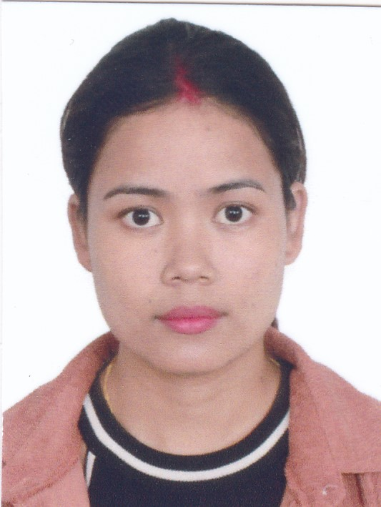
COOKING | √
WASHING | √
IRONING | √
GARDENING | √
SEWING | -
CHILDREN CARE | √
OLD PEOPLE | √
SICK PEOPLE | √
COMPUTER OPER | -
NURSING | -
MASSAGE | -
CAR WASH | -
APPLICATION FOR EMPLOYMENT

OUR REF. No: JAS/761/2022 | DATE: 08/08/2022

SURNAME: LAMA
NAME: MANISHA
Date of Birth: 22/09/1996 |  |  |  |  |  |  | Place of Birth: Parsa
AGE: 27 Years |  |  |  |  |  |  | Religions: Buddhist
ADDRESS: Nirmalbasti-02, Parsa
Married: √ |  |  |  | Single: |  |  |  |  | Divorce: |  |  | Widow:
Children No: 1 Son |  |  |  |  |  |  |  |  | Age: 6 Years
Passport No: 10146093 |  |  |  |  |  |  |  |  | Date of Issue: 15/12/2016
Place of Issue: Kathmandu |  |  |  |  |  |  |  |  | Date of Expired: 14/12/2026
Male: |  |  |  |  |  |  |  |  | Female: √
Educational Qualification: S.E.E.
DIPLOMA:
POSITION DESIRED: HOUSE MAID
LANGUAGES YOU CAN SPEAK
 |  | Zero |  |  | Poor | Fair |  |  |  |  | Good |  | Very Good
ENGLISH |  |  |  |  |  | √
GREEK |  |  |  |  |  | √
WORK EXPERIENCE & WHERE
No | TIME |  |  | PLACE |  |  |  | POSITION
1. | 2 Years |  |  | Nepal |  |  |  | House Maid
2.

3.

4.

HEIGHT: 155 Cm |  |  |  |  |  |  |  | WEIGHT: 55 Kg
Smoking:  No |  |  | Do you take alcohol:  No |  |  |  |  |  |  | Driving Licence:  No  Categories:
REMARKS:

Contact Telephone: 00977-9848666787
COPY OF PASSPORT | 